A Guide to Developing a CPD Group Learning Event:

What Planning Committee members need to know

Robert Parson, M.Ed.Directeur, Formation et agrément/Director, Education and Accreditation Développement professionnelle continue / Office of Continuing Professional Development Email: rparson@uottawa.ca

A Guide to Developing a CPD Group Learning Event: What planning committee members need to know

Introduction
Thank you for joining a planning committee. You play a vital role in developing a scientific program which responds to the needs of the target audience and is based on best practice in education development. The purpose of this guide is to help you understand the various aspects of planning a conference or course which will be the most impactful for the learners.
This design process is based principally on the work of Kern (2009) and Diamond (2008) with substantial input from professional and educational development colleagues from Canada and abroad. The following graphic illustrates the steps to the design of an education program. The components of the process will be discussed further in the following pages.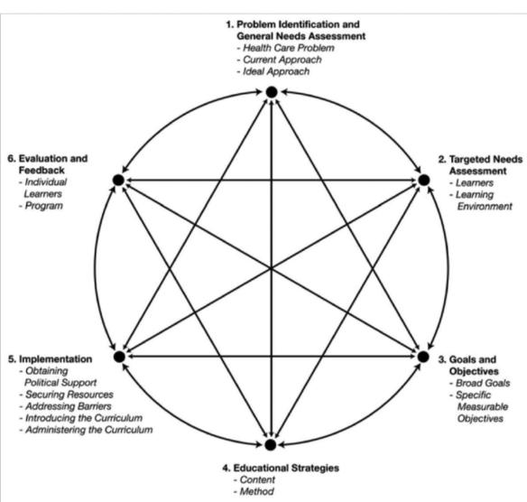
Kern, D.E., Thomas, P.A. and Hughes, M.T. “Curriculum Development for Medical Education: A Six Step Approach” (2009) Second Ed.

Problem Identification and General Needs Assessment
The first thing the commmittee must do is decide which group of learners are the focus of this conference: the target audience. The committee should specify those health care professionals who would benefit from participating in the conference, and the committee should adequately represent the target audience to be able to make appropriate decisions about needs and content.
The next step is to define what problems and needs will be addressed by the conference. This should occur early on in the process. As you think about the target audience and their educational needs, identify potential sources of information that would help you to identify these needs. The following are things to consider as you go though this planning process.

a) Define the Health Care Problem
The goal of this step is to describe the "health care problem" that this conference or course is addressing. Begin with looking at the “whole” before zeroing in on the specifics.

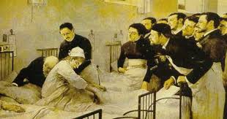

Consider in the discussion:
Who is affected? Stakeholders could include…
- Patients
- Medical personnel
- Society

b) Describe the Need
The following are different kinds of educational needs of the target audience:

Unperceived (objective) needs | Unperceived needs are gaps between the present situation and optimal care that a learner does not know exist; when learners do not know what they do not know.  They address the gap from the experts’ point of view: what are the problems related to the perceived health issues? For example:  - There may be new developments in the field that should be explained or communicated.  Or  - There may be specific issues such as challenges in diagnosing certain specific conditions that are very prevalent and have serious implications  Given the areas for which you wish to investigate the need, choose the methods you wish to use:  - The published literature, syntheses of the literature, guidelines?  - Sources of quantitative data that would provide information about the problems?  - Barriers to change and ways to overcome barriers?  Examples of tools to identify them can include  ☐ Self-assessment tests  ☐ Chart audits  ☐ Chart stimulated recall interviews  ☐ Direct observation of practice performance  ☐ Quality assurance data from hospitals, regions  ☐ Standardized patients  ☐ Provincial databases  ☐ Incident reports  ☐ Published literature (RCT, cohort studies)  ☐ Other: please specify:
Perceived (subjective) needs | Perceived needs address the gap from the learners’ point of view. What are they looking for? What is most important to them and their patients?  - Would a questionnaire or survey for potential attendees provide the kind of info you need?  - Would focus groups?  - Do you suspect that the gaps in best practices exist due to lack of knowledge, skill, a need for change in how the profession deals with something, glitches in the system, communication issues?  - Have you made sure to include feedback from your specific target learners?  - Consider barriers to change  Examples of tools to use to identify them can include:  ☐ Questionnaire or survey – of target learners  ☐ Opinion of Planning Committee – including target learners  ☐ Focus groups- including target learners  ☐ Other: please specify:

Gap Analysis
Once the educational needs are identified, they can be developed further through a GAP ANALYSIS. These steps do not have to follow this exact sequence. For example, you may search the literature, identify a part of the need and then go back to some target learners or data source for more information.

Complete the following:
- Current Situation - Fill in the first column of the Needs Analysis Table.
- Integrate your research on the topic and need.
- Ideal (or better) Situation - Fill in the third column of the table.
- Gap/Need – Fill in the second column after reading through section b) of this workbook.

Needs Analysis Table (Health Care Problem)
Current Situation | Gap / Need | Ideal Situation
What is the current situation? |  | What would the ideal (or much better) situation look like?

c) Describe your target learners
Identify: what are their skills, attitudes, goals, needs? Answer as many of the following questions as are relevant to the project.
Instructions:
Some questions you can ask include:
  - Aside from clinical knowledge, consider other aspects that could impact the current situation and influence the format of the program?
  - Entry-level skills - what can they do before the lesson...?
  - What do they see as the gap in terms of the subject of the learning activity?
  - What are their preferences (for learning, times, frequency, size, difficulty, etc.)?
  - Motivation (what will get them going; intrinsic, extrinsic)?
  - What barriers or enabling factors should be considered?
  - What CanMEDs (FM) roles would be affected?
  - Other...?

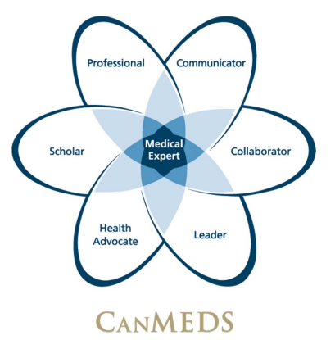

2. Writing Learning Objectives for CPD Programs
All accredited CPD programs and sessions must have clear and observable learning objectives. Let’s start with defining a learning objective.

Definition of a learning objective
A Learning objective is a description of the skills, abilities and/or attitudes expected of the participant by the end of the program, session or learning activity.
NOTTTTTTTTTTTTTTTT…
“What would you like to teach your participants by the end of your session?”

Purpose of learning objectives
- They help you as a presenter or as a program planner, because they provide a focus and parameters around your presentation or program.
- They provide a cognitive map for your participants.
- They help the participants to organize information, assess their progress, and support them in achieving those objectives.

The Essence
The learning objective should describe what the participant will be able to
- DO at the end of the session
Or
- DEMONSTRATE at the end of the session

Common Errors
The most common errors in writing learning objectives are:
- Describing what the presenter will do, rather than what the participant will be able to do at the end of the session.
- Using a fuzzy, non-observable action verb, such as “understand”, “know”, “appreciate”, “value”, etc. Refer to The Sinister Sixteen in this document for a list of the verbs to avoid.

Consider this scenario…
Just imagine it is the end of the lesson and you turn to a participant and say: “Dr. X, could you please… (Insert your learning objective)”
- What would you want to see your learners doing?
- Consider the needs assessment; what is needed to answer the challenge?
- If you did write “understand” or “appreciate”, etc., what did you really mean they would DO with that understanding or appreciation?

3. Resources
Bloom’s Taxonomy (below) is a useful tool for considering the level of cognitive challenge that you want your participants to reach.
Review the need for the topic, the need for the learning activity and reflect on the type of outcome that would best suit that need or fill that gap.
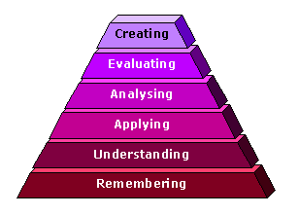
Revision of Bloom’s taxonomy of the cognitive domain following Anderson and Krathwohl (2001)

Verbs to Use in Writing Learning Objectives
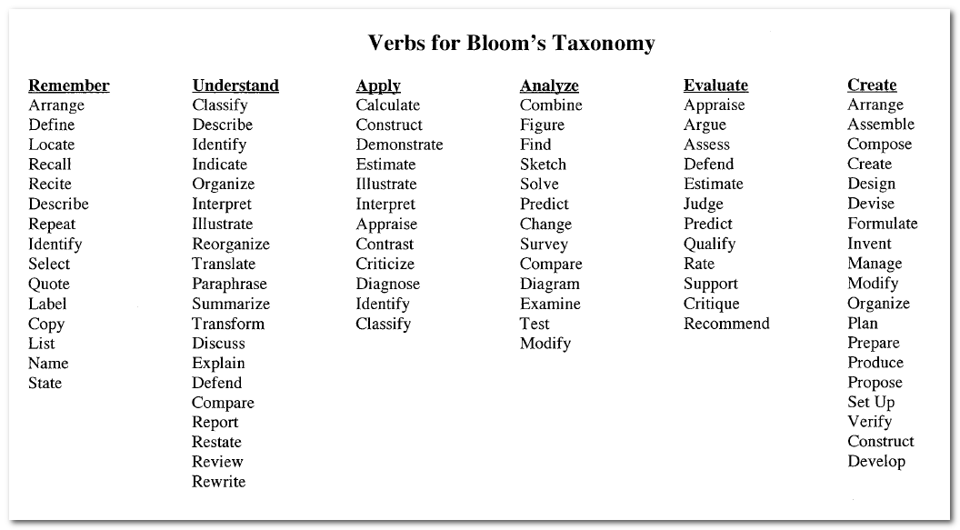

The Sinister 16!!! Vague Verbs to Avoid
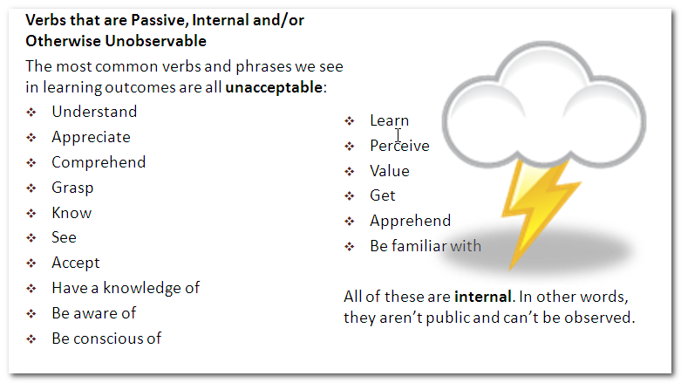

4. Learning Formats – Teaching and Learning Activities
What kind of ways can learners interact with your content?
- Large group sessions
- Small group sessions
- Case-based discussions
- Flipped classrooms (content before the session, discussion during the session)
- Assessment and feedback

Identify and Engage with Speakers, Facilitators and Presenters
The planning process should not stop at developing learning objectives and naming sessions. Selecting and approaching the deliverers of the content (speakers, facilitators, presenters) is extremely important.

Ideally, planning committee members should interact directly with content experts to provide the rationale for their session:
- Needs
- Practice gaps
- Clinical questions to be answered
- Barriers to implementation

Speakers should consider incorporating behaviour change techniques which would enable or motivate learners to change their practice. A list of potential techniques are provided below.

Behaviour Changing Techniques (Abraham, Michie): When developing your program, it is worthwhile to consider including various opportunities to enable practice change. The following provides some general types of behavioural change techniques that could be introduced either by the planning committee within learning objectives or as a guide to speakers/facilitators when they are developing their sessions: 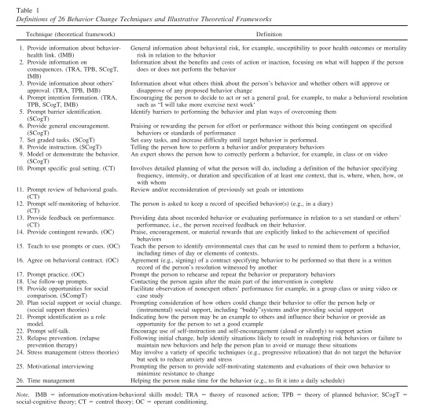

References
- Abraham C, Michie S. A taxonomy of behaviour change techniques used in interventions. Health Psychology, 2008, 27:379-387
- Anderson, L.W., & Krathwohl (Eds.). (2001). A Taxonomy for Learning, Teaching, and Assessing: A Revision of Bloom's Taxonomy of Educational Objectives. New York: Longman. Available at: http://www.jstor.org/stable/1477405?origin=JSTOR-pdf
- Diamond, Robert M. (1998) Designing and Assessing Courses and Curricula: A Practical Guide. Jossey–Bass (San Francisco)
- Forsetlund L, Bjorndal A, Rashidian A et al. (2009) Continuing education meetings and workshops: effects on professional practice and health care outcomes. Cochrane Database Syst Rev 2009; 2: CD003030.
- Kern, D.E., Thomas, P.A. and Hughes, M.T. Curriculum Development for Medical Education: A Six Step Approach (2009) Second Ed., the Johns Hopkins Univ. Press. (Baltimore)
- Knowles, M. S., Holton, E. F., & Swanson, R.A. (1998).A theory of adult learning: Andragogy. In The adult learner: The definitive classic in adult education and human resource development (5th ed., pp. 35-72). Woburn: Butterworth Heinemann.
- McMaster University Faculty of Health Sciences Continuing Health, Sciences Education Program (2009)Guidebook for Planning and Delivering Continuing Professional Development Programs and Events,pp. 9-11
- Michie S, Johnson M, Abrahm C, Lawton R. Parker D, Walker A, on behalf of the “Psychological Theory” Group. Making psychological theory useful for implementing evidence based practice: a consensus approach. Qual Saf Health Care 2005;14:26-33.
- Moutrie, R. R. and Lockyer, J. (1996), Continuing medical education handbook: A resource for CME practitioners. Stephen Biddle and Barbara B. Huffman. J. Contin. Educ. Health Prof., 16: 125–126. doi: 10.1002/chp.4750160209
- Retrieved and adapted from Royal College of Physicians and Surgeons of Canada http://www.royalcollege.ca/portal/page/portal/rc/common/documents/cpd_accreditation/learning_formats_e.pdf
- Royal College of Physicians and Surgeons of Canada (2014) Identifying the educational needs of the target audience

