UGME Curriculum Renewal
PROJECT CHARTER

Faculty of Medicine, University of Ottawa
Last updated: 15/02/2021
Prepared By: Dr Craig Campbell
Version 7, February 15, 2021

Table of Contents
Contents
1. Introduction 3
2. Overarching Objective for Curriculum Renewal 3
3. Project Scope, Goals and Measureable Outcomes 3
4. Themes for Curriculum Renewal 6
5. Educational Principles for Curriculum Renewal 7
6. Staged Implementation Plan 8
7. Project Budget 9
8. Communications 10
9. Project Limitations 10
10. Project Organization 11
a. Project Governance and Team Structure 11
b. Roles and Responsibilities 11
11. Authorization 12
12. Document Change Control 13

- Introduction

The last major renewal of the UGME Program at the University of Ottawa’s Faculty of Medicine occurred in 2008 and resulted in a shift from problem-based learning (PBL) to case-based learning (CBL), a reduction in the time allocated for didactic teaching with more time allocated for self-directed learning, and a number of technological and educational innovations, including but not limited to self-learning modules, team-based learning, flipped classroom strategies and integrative lectures, were introduced. These changes were accompanied by revisions to the UGME competencies and program objectives. Since 2008, a spirit of innovation has continued resulting in the implementation of a number of specific initiatives to meet evolving educational and student wellbeing needs, and to address areas identified for improvement during on site accreditation visits. However, there has not been a comprehensive review of the curriculum’s mission, purpose, educational design, or intended outcomes in over a decade.

- Overarching Objective for Curriculum Renewal

The curriculum renewal project will be principally organized to address the following question.

“What are the characteristics, qualities, professional values and abilities that define a graduate of the Faculty of Medicine at the University of Ottawa?”

Coming to consensus on the overall purpose or intent of the curriculum will serve to guide decisions on strategic directions, goals and intended outcomes to be pursued by the curriculum renewal project. This project reflects our collective commitment to pursue excellence.

Project Scope, Goals and Measurable Outcomes

The scope of the curriculum renewal project is reflected by the following goals, objectives and measurable outcomes. These goals collectively reflect identified strategic priorities for curriculum renewal, including our commitment to address all accreditation standards that require improvement.

Prior to the launch of the curriculum renewal project several working groups were already formed or in development. An Ethics Working Group under the leadership of Dr. Francis Bakewell and a POCUS Working group under the leadership of Dr Michael Woo and Dr. Nicolas Chagnon, had already started work on revisions within these components of the curriculum. In the May 2020 a working group was proposed to develop a curriculum on anti-racism based in part on a curriculum audit. Dr. Ewurabena Simpson has subsequently formed a working group to create a longitudinal curriculum on anti-racism and race conscious education. Each of these working groups are included as integral components of the Curriculum Renewal Project and will report their recommendations directly to the Curriculum Content Review Committee (CCRC).

In addition to the three working groups described above, eight working groups will be established to define a strategic direction for curriculum renewal. Each working group during phase 1 of curriculum renewal will be tasked with identifying gaps, opportunities and proposing recommendations which will be integrated within a report for a staged implementation plan which will take place between September 2022 and June 2024. Based on the findings from stage 1 of the curriculum renewal project, additional working groups will be launched in September 2021 and tasked with revising or enhancing current content.

Goals | Objectives | Measurable Outcomes
Create a description of the characteristics, qualities, values and abilities of a University of Ottawa Faculty of Medicine graduate. | Primary Objective  - Create a mission statement for the UGME Program curriculum.  Secondary Objectives  - Review and revise the current UGME program objectives to align with vision, mission, values and strategic priorities of the Faculty of Medicine. | - A description of a uOttawa graduate will be developed  - A UGME Program mission statement will be created for approval by CCRC and UCC by May 2021.  - A revised description of the UGME program objectives will be created and approved by CCRC and UCC by June 2021.
Implement the national EPAs for the class of 2026. | Primary Objectives  - Create a national EPA implementation plan by June 2021.  Secondary Objectives  - Identify the tasks students will be expected to perform for each EPA by the end of pre-clerkship and clerkship.  - Identify the knowledge, skills, attitudes and behaviours that students will require by the end of pre-clerkship and clerkship to demonstrate achievement of each EPA by the end of clerkship.  - Identify the information sources that will collectively inform decisions on EPA achievement. | - The national EPA implementation plan will be developed for approval by CCRC and UCC by June 2021.  - A plan to pilot elements of the national EPA implementation plan during the 2021-22 academic year will include:  - Revisions to assessment strategies for pre-clerkship and clerkship.  - An faculty development program to support EPA implementation.  - The technology support system required to summarize data sources related to individual EPAs.  - The process to monitor student progression across the pre-clerkship and clerkship.
Complete a review of the curriculum’s structure and educational design. | Primary Objective  - A review of the curriculum’s structure and educational design will be completed by May 2021.  Secondary Objectives  - Align any proposed UGME Program structural changes with:  - UGME Program’s educational mission statement;  - EPA implementation; and  - Recommendations to enhance learning strategies and the integration of current and new content areas. | - An analysis of the UGME program’s structure will be presented for discussion at CCRC and UCC by June 2021.  .
Define the components of an integrated social accountability program for UGME. | Primary Objective  - Complete a review and analysis of the social accountability curriculum.  Secondary Objectives  - Propose recommendations for the implementation of social accountability concepts, skills, behaviours across the UGME Program by June 2021.  - Identify strategies to facilitate the alignment between community needs and curriculum content. | - A plan for integration of social accountability concepts, skills and behaviours across the curriculum will be defined by June 2021.
Construct a framework for an integrated longitudinal Interprofessional Education program in UGME. | Primary Objective  - Complete a review and analysis of the current interprofessional education curriculum.  Secondary Objectives  - Propose recommendations for the integration of interprofessional education across the UGME program.  - Identify strategies to assess the competencies students require to function as effective members of IPE health care teams.  - Identify strategies to prepare students for interprofessional collaborative practice. | - A plan for integrating a framework for an integrated longitudinal Interprofessional Education program in UGME will be created by June 2021.
Construct a framework to enhance the role for patients and communities within the UGME Program. | Primary Objective  - Create a strategy to enhance the role for patients in the education and assessment of students.  Secondary Objectives  - Facilitate alignment between patient needs and curriculum content.  - Create a plan for fostering community and patient partnerships in guiding curriculum renewal. | - A plan to enhance the role for patients as teachers, assessors, and advisors to the curriculum will be created by June 2021.  - A plan to regularly identify current and future community needs for inclusion in the curriculum will be defined by June 2021.
Enhance the application of education technology in UGME Program. | Primary Objective  - Create a plan for how education technology will enhance learning, teaching and assessment within the UGME Program.  Secondary Objectives  - Identify a technology platform that will enable achievement of the UGME competencies and program objectives.  - Develop a strategy to create a robust education technology support system.  - Expand current simulation based education and assessment strategies. | - A plan to enable education technology within the UGME program will be completed by June 2021.  - A platform and support system for the UGME program will be identified by September 2021.  - A plan for utilizing simulation to enhance clinical, procedural skills development and team-based learning and feedback will be completed by September 2021.
Enhance the effectiveness of current and future assessment strategies within the UGME Program | Primary Objective  - Create a plan to expand or enhance assessment strategies, processes and tools across the UGME program.  Secondary Objectives  - Identify and propose recommendations to integrate the assessment of EPAs across the pre-clerkship and clerkship.  - Identify and address gaps in the assessment of core curriculum elements.  - Identify the infrastructure required to support low-stakes and high-stakes assessment strategies. | - A plan for how to enhance the reliability, validity and educational impact of assessment strategies will be completed by June 2021.  - Introduction of new assessment strategies or tools will be identified starting in September 2021.

- Themes for Curriculum Renewal
The following themes will serve as a framework to facilitate the integration of the working group recommendations identified by multiple working groups, analysis from surveys and focus groups, and a review of the evidence that informs the achievement of the goals for curriculum renewal. Each theme is relevant to one or multiple working groups. These themes will contribute to our ability to meet and exceed accreditation standards in our commitment to pursue excellence in all that we do.

Theme 1: Competency-based

This theme will focus on how competencies can serve as an organizing framework for how we conceptualize the curriculum’s content, assessment strategies, and structure. A competency-based education program will align the curriculum’s content (the knowledge, skills, attitudes and behaviours) and assessment strategies with the professional tasks that students will be expected to perform when entering residency training.

Theme 2: Technology

This theme is focused on how education technology can enhance the curriculum’s content development and delivery; support student learning; expand opportunities for deliberative practice; and enhance alignment between our educational process with health care delivery models.

Theme 3: Community

This theme is focused on enhancing the alignment of the curriculum’s content with community needs and expectations and the role for patients as educators, assessors and advisors in educational policy development.

Theme 4: Equity

This theme is focused on enhancing the equity of student learning opportunities and clinical experiences of francophone and anglophone students across the breadth of the learning environments aligned with the UGME Program. This theme will focus on addressing the resources required for both anglophone and francophone streams to achieve the goals and objectives of the MD Program at uOttawa.

Theme 5: Wellness

This theme is focused on how curriculum renewal can enhance the wellbeing of students, faculty, administrative staff and patients who participate in the design, delivery or evaluation of the curriculum.

Theme 6: Generalism

This theme is focused on establishing the appropriate balance between generalism and specialism in achieving the mission of the UGME program and ensuring students have achieved the MD Program’s objectives to enable their successful transition to residency training.

Theme 7: Assessment

This theme is focused on strategies, processes and tools to enhance the validity and educational impact of low and high stakes assessment strategies and identifying opportunities for how assessment can enhance student learning and expand evaluation of UGME program objectives.

Theme 8: Adaptability

This theme is focused on strategies, processes and tools that facilitate the ability of the curriculum to adapt to evolving needs and address areas for continuous quality improvement in a timely manner.

- Educational Principles for Curriculum Renewal
The curriculum renewal project will be guided by the following educational principles:

The Curriculum’s;
- content will be current, evidence-informed, and patient-centered;
- educational processes will promote active learning, continuous growth and the professionalism of students;
- educational activities will be integrated, appropriately sequenced and focused on the knowledge, skills, and abilities of a generalist physician;
- educational design will enable students to become reflective practitioners with the ability to function as effective members of interprofessional health teams; and
- structure will pursue equity across language streams and all learning environments.
- Staged Implementation Plan

The Curriculum Renewal Project will utilize a staged implementation plan.

Project Stages | Key Milestones
Stage 1:  Defining the Priorities for  Curriculum Renewal  September 2020 – June 2021 | - Recruit a Curriculum Renewal Leadership Team (CuRL).  - Create a project charter for approval by Curriculum Content Review Committee (CCRC) and Undergraduate Curriculum Committee (UCC).  - Establish the overarching objective, themes, goals and measurable outcomes for curriculum renewal.  - Create a detailed project plan for review and approval by CCRC and UCC.  - Launch a series of working groups to address the established goals.  - Analyze and integrate working groups recommendations into a report on curriculum renewal.  - Select and implement a program evaluation model for the UGME program.  - Identify the Key Performance Indicators for curriculum renewal
Stage 2  Design a Curriculum  Renewal Plan  July 2021 – June 2022 | - Create a staged curriculum renewal implementation plan  - Launch additional working groups to revise curriculum content and sequencing.  - Pilot changes across multiple domains including education and assessment strategies and technological infrastructure requirements  - Launch a Faculty Development Program to support curriculum renewal for UGME  - Submit recommended curriculum changes (new program objectives; course codes) to the University Senate by November 2021.
Stage 3  Implement the Curriculum Renewal Plan  September 2022 – June 2024 | - Implement approved changes to the curriculum’s structure and content  - Implement technological support systems  - Launch any new courses / content  - Implement any new assessment methods  - Continue to build faculty development and program evaluation strategies  - Refine the learning analytics strategies in Elentra  - Sustain program evaluation data collection and analysis processes.  - Create a scholarship strategy for publishing innovations related to curriculum renewal.
Stage 4  Sustain Curriculum Renewal  July 2024 - 2026 | - Make adjustments to the initial implementation process and plans.  - Create a continuous curriculum renewal plan.  - Prepare documentation for accreditation.
- Project Budget

The following section describes the types or categories of expenses that the project might encounter over its duration. Given the magnitude of this undertaking, these itemized expenses are subject to change based on the evolution of the project. The expenses will be forecasted annually with the assistance of the managing director who will be responsible for the yearly budget.

Item | Description
Curriculum Renewal Personnel | UGME permanent staff
Creator of CBL SLM modules | Faculty members and MedTech
Community members CuRL | Annual stipend
Community members for working groups | Annual stipend
Software | Various software including: membership for Doodle, MS Project, licence Survey Monkey, licence Zoom, other
Technologies | Acquisition of new teaching technologies
Communications tools | Poster prints  Promotional tools  Other
Office supplies | Various office supplies  Prints and photocopies  Other
Meeting expenses | Catering/snacks  Transportation  Parking  Prints and photocopies  Name tags  Additional temporary staff  Other
Copy rights | Copy rights related costs
Other related expenses | To be determined
Staff training | If needed for new technologies

- Communications

These are the types of communications tools that will be used for our marketing strategy to reach both internal and external stakeholders. A separate communications plan will also be developed on a yearly basis based on the evolution of the project.
Internal Stakeholders | External Stakeholders
Faculty of Medicine Website | Faculty of Medicine Website
Faculty, Student and Staff surveys | Community/patient surveys
Social Media Channels | Social Media Channels
Newsletters (Listservs) | Newsletters (hospitals and community mailing lists)
Promotional posters | Promotional posters
Informational bulletin | Informational bulletin
Promotional products | Promotional products
CuRL Meeting minutes | Media campaign
Working group reports | Social media
Project Dashboard and Status reports

- Project Limitations
Category | Limitations
Deadline | The implementation of curriculum renewal will support the implementation of the national EPAs by fall 2022.
Accreditation | Curriculum renewal will address all accreditation requirements
Budget | There are adequate resources required to support proposed changes
Technology | Proposed technologies and required training are available and implemented to support the timelines for curriculum renewal.
Implementation time | Administrative requirements, faculty needs, technological needs, budgetary restrictions will support the staged implementation plan
Adoption/training | Training and development programs will address the needs of students, faculty and administrative staff.
- Project Organization
  - Project Governance and Team Structure

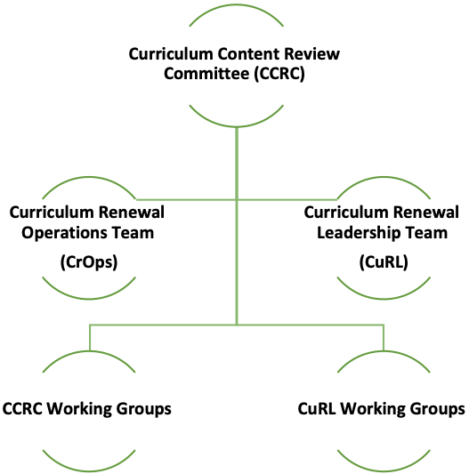

  - Roles and Responsibilities
Responsible (R)  The team member who does the work to complete the task | Consulted (C)  People who provide input on a deliverable based on the final review on a task before it’s deemed complete
Accountable (A)  The person who delegates work and provides final review on a task before its deemed complete | Informed (I)  People who need to be kept in the lop on progress project

 | Project Planning | Communications  &  Marketing | Working Groups | Implementation | Finance | Assessment

Internal Stakeholders
UGME Vice-Dean | I | I | I | I | I | I
UGME Director | I | I | I | I | R | I
Curriculum Director | A | A | A | A | A | A
Curriculum Renewal Director | A | A | A | A | A | A
Project Manager | R | R | C | A | A | A
Supervisor Assessment, Evaluation and Curriculum Office | A | A | A | A | A | A
Curriculum Renewal Coordinator | C | I | R | R | I | A
Curriculum Coordinator | C | I | R | R | I | A
CuRL Members | C | C | C | C | C | C
CCRC Members | I | I | I | I | I | I
UCC Members | I | I | I | I | I | I
Working Group Members | I | I | R | R | I | R
Program Directors | C | I | C | R | I | R
Clerkship Rotation Directors | I | I | I | R | I | R
Faculty | C | I | C, R | R | I | R
Students | C | I | C, R | C | I | C

External Stakeholders
Educational Partners | C | I | C | C | I | C
Patients | C | I | C | C | I | C
- Authorization
This project charter formally authorizes the existence of the project, ‘University of Ottawa Faculty of Medicine’s Undergraduate Education Curriculum Renewal’ and provides the project manager with the authority to apply organizational resources to project activities described herein. If there is a change in the project scope, the project charter will be updated and submitted for re-approval.

__________________________________________________ ____________________
Dr. Heather MacLean Date
Director of Curriculum Renewal
Faculty of Medicine, uOttawa

_______________ June 07,2022
Dr. Craig Campbell Date
Curriculum Director
Faculty of Medicine, uOttawa

____________________________________________________________ March 10, 2021
Dr. Melissa Forgie Date
Vice Dean UGME
Faculty of Medicine, uOttawa

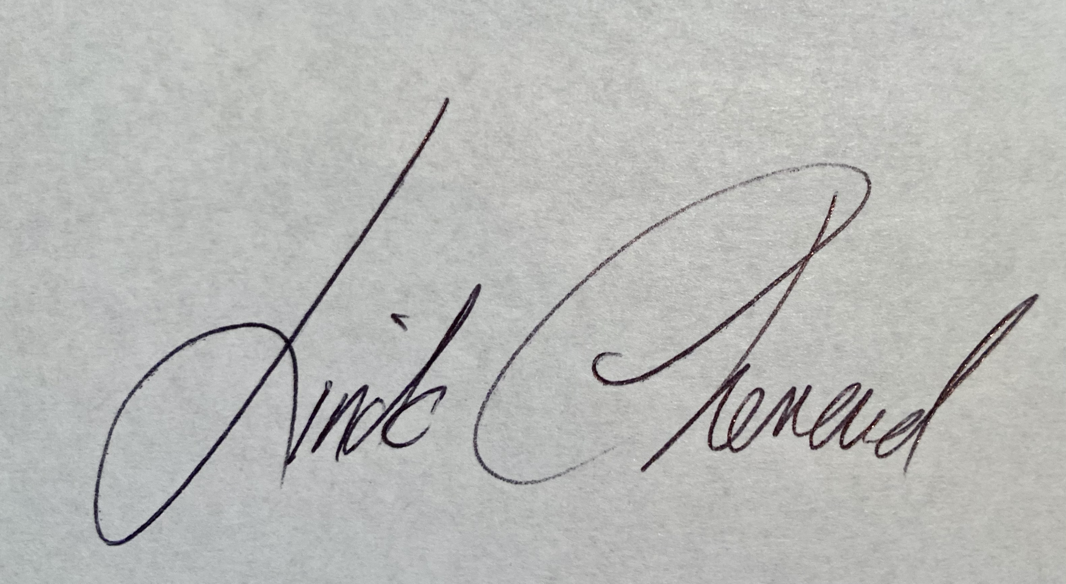 March 12, 2021.
____________________________________________________________ _______________________
Linda Chenard Date
Director UGME
Faculty of Medicine, uOttawa

____________________________________________________________ ___Mar-16-2021_________________
Lyne Charlebois Date
Senior Management, Information Management Services
Faculty of Medicine, uOttawa

____________________________________________________________ _______________________
Sibylle Berger Date
Project Manager, Curriculum Renewal
Faculty of Medicine, uOttawa

- Document Change Control
This section serves to control the development and distribution of revisions to the project charter. It is recommended that changes to the project charter be documented only by adding annexes to the original project charter. This will keep an accurate history of the original document that was first approved.
Revision Number | Date of Issue | Author(s) | Brief Description of Change
1.0 | Nov. 26, 2020 | Sibylle Berger | Original version Project Charter
2.0 | December 1, 2020 | Craig Campbell | Revisions include a listing of six Project Themes; revisions to the Goals; Objectives and Outcomes section
3.0 | December 15, 2020 | Craig Campbell | Revisions, based on feedback from the CuRL team members included adding a new section to describe the overarching objective for curriculum renewal; revising the goals for curriculum renewal to correspond with established working groups; revised the educational principles section; reorganized the sequencing of the sections of the document.
4.0 | January 5, 2021 | Craig Campbell | Further revisions to the goals, themes and educational principles
5.0 | January 17, 2021 | Craig Campbell | Revisions to the description of several goals based on feedback from CuRL members.
6.0 | January 25, 2021 | Craig Campbell | Revisions to the Overarching Objective section to include the goal of pursuing excellence; revisions to several themes to enhance clarity and revisions to the educational principles based on CCRC feedback
7.0 | February 15, 2021 | Craig Campbell | New content included within Section 3 to include three pre-existing working groups in Ethics, POCUS and anti-racism are part of the scope of the project and will report directly to CCRC. Minor editing to enhance clarity that future stages will be based on the outcomes of stage 1.
8.0 | Mars 2021 | Muriel Miezan | Sybille Berger left the position as Project Manager
9.0 | January 10th, 2022 | Muriel Miezan | New Project Manager
10.0
11.0

