User Guide for Behavior Core
13800 Coppermine Rd,
Herndon, VA 20171
Phone: 1-800-506-5905
Email: support@IdeaElan.com
INFINITY
Idea Elan
2020
Comprehensive Online Solution for Lab and Core Facility Management

Contents
Login Instructions 3
Internal Users 3
External Users 3
New User Sign-up (For external users only) 4
Setting Up Your Lab 5
How to Add A New Student to Your Lab 5
How to Remove a User from Your Lab 6
How to Add a Lab Manager 6
Adding/Managing Your Billing Account/FOAP 6
Additional Training Information 6

Quick Startup Guide

Login Instructions

Internal Users
Users with University of Ottawa login ID can use their credentials to log in and will be redirected to Infinity.
Internal User Login URL: https://secure17.ideaelan.com/secure/Public/AppLogin.aspx

External Users
External users will use the Infinity start page. Existing users can enter their information the username and password fields in the top right corner. New users will have to register using the “Get started, register here for free” option.
External Users Login URL: https://secure17.ideaelan.com/uOttawa_Test/Public/AppLogin.aspx
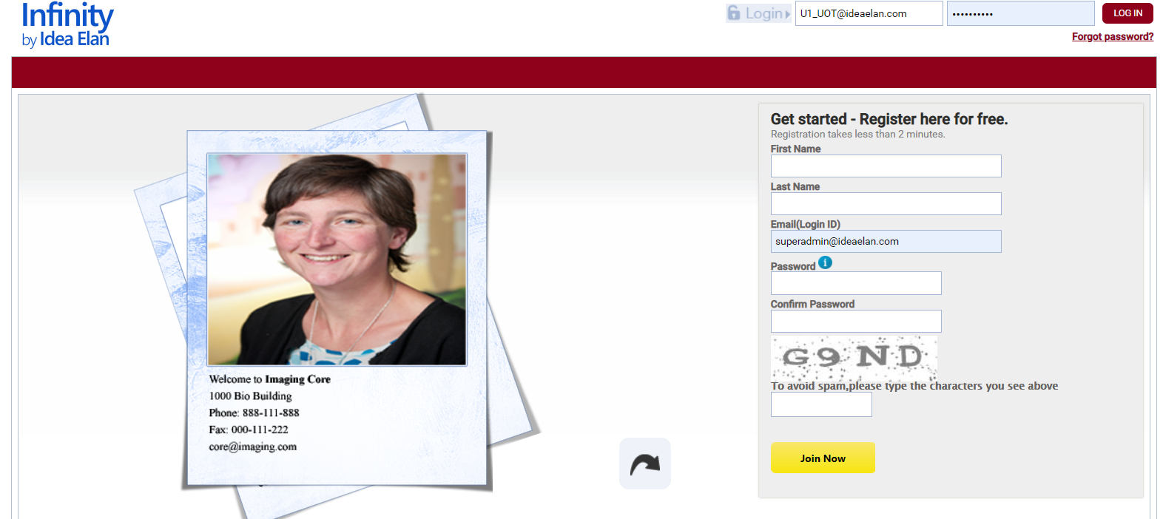

New User Sign-up (For external users only)
New External Users can register on the login page of the Infinity link.
- Enter First Name, Last Name, Email ID, Password and click on the Join Now Button.

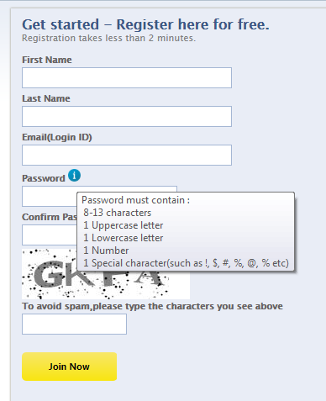
Click on Join Now Button
Enter the user ID here
Enter the password here
- After registering, a confirmation message will appear on the screen. Click the verification link sent to the email you provided.

- Once the verification link has been clicked and verified, the page will be redirected to a registration wizard.
- Click on the start button in the registration wizard to set up your Infinity account and profile.

Setting Up Your Lab
Your lab should already exist in the Infinity website. If it does not, please contact behcore@uottawa.ca so we can create it for you.
The PI/Lab Admin page toolbar will allow you to set up your lab and manage users, facility access, and your billing preferences.
- Inbox: Review user requests, new invoices, manage sample submissions and projects, and add publications
  - Lab Access Requests: Approve or reject new lab access requests
  - Invoices: Review, modify, and approve invoices
  - Sample Submission: Monitor sample submissions to other cores
  - Projects: Manage ongoing projects and milestones
  - Dashboard: See reservations, sample submissions, and supplies in one place
  - Publications: See and manage publications
- Lab: allows you to control your labs basic details, billing accounts, and settings.
  - Basic Details: Change the name of your lab, your contact information, and add users
  - Billing Information: Select FOAPs that will be used by Core facilities to bill your lab, and specify what FOAPs each user can use.
  - Lab settings: Set maximum spending limits for users, set a lab administrator, and set if invoices can be manually or automatically approved.
- Facilities: Request access to Core facilities as needed. You should already have access to the Behaviour and Physiology Core.
- Users: Add new users, manage users information, see FOAP approval for each user
- Reports: Run reports based on a variety of criteria
- Supplies: Manage inventory

How to Add A New Student to Your Lab
There are two ways to add a new student to your lab:

Option 1: A new student requests access to your lab
- Under the Inbox tab – Lab Access Requests, you will be able to see requests from potential lab members.
- Approve or reject users as needed.
Option 2: The new student already exists in the system
- Go to Lab – Basic Details – Add Users.
- Scroll through the list to find the user. Check the box in front of the user and click the right-facing arrow to move it to the “Selected” box.
- Click UPDATE.

Option 3: The user is completely new.
- Go to the Users tab. Click “+ADD NEW USER”.
- Fill out the Add New User pop-up box and click CREATE.
- If you need to add multiple users, you can use the “Import from Excel” option.

How to Remove a User from Your Lab
Users can not be deleted, but they can be deactivated.
- Go to Lab – Basic Details – Add Users.
- In the “Selected” box on the right, click the user to be removed. Click on the left-facing arrow to move the user to the “Available to Select” box.
- Click UPDATE.
- Go to the Users tab. The user should now have a “Inactive” note under Status.

How to Add a Lab Manager
- Go to Lab – Lab Settings.
- Check the box in front of “Lab Admin Alternative”. A dropdown menu will appear next to this option.
- From the dropdown menu, select the user that you would like to be the lab manager/admin.
- Click UPDATE.

Adding/Managing Your Billing Account/FOAP
- Go to Lab – Billing Information. You should have a list of current FOAPs associated with your lab.
- You can Edit each account using the pencil icon, or delete the fund by clicking the red X icon.
- You can add new accounts in the table above the list of FOAPs by adding in the required information.
- When done, click UPDATE.
- If you need additional information, contact your finance department.

Additional Training Information

Idea Elan provides a recorded training session from November 2020 at the links below. You can also contact behcore@uottawa.ca if you have additional questions.

https://us02web.zoom.us/rec/share/PkExltzIeCk8SBobH9TJxqMotLx8x8EwTaQ_216JeyjmY2iWkhVRkbElqXwuQkX.9MaggfjQCGFDypkR
Passcode: ?L7R2q+Q

https://us02web.zoom.us/rec/share/Y-aYqwEHvCqqE-59sFCXPNgtbEQOFcyBMLRl2ngH_ofLmuRYVzp2QElD2juFEzf.xzdrGrRPhTDz6n9J
Passcode: =+3#6lqf

